**[IS216] Extra Exercises - Week 3 - Bootstrap**

**Objectives**

● To understand how the use of bootstrap enables styling of HTML elements

● To apply the use of bootstrap to HTML web pages.

**Instructions**

● Questions with no asterisk mark are easy peasy.

● Questions marked with * are slightly challenging.

● Questions marked with **\***\* are challenging.

● Questions marked with *** are very challenging.

**Download**

● **Resources**: Click[here](https://smu-my.sharepoint.com/:f:/g/personal/lkshar_smu_edu_sg/EuZyX_DIMwxFqBd7KbTjSeMB5KaxXBzgvehx1_s4HB-zIw?e=1tQRpO)

* **Sample Solutions:** Click [here](https://smu-my.sharepoint.com/:f:/g/personal/lkshar_smu_edu_sg/Eln08yPSXwxBuofxje3G3bQBTJ4Zb7ATC-06K9fkguIUBQ?e=EjrRzR)

**NOTE:** If you spot any mistakes/errors in the questions, please contact your instructors by email and state the issues. We will try to address it as soon as possible.

# 

**Question 1 – Fanpage (*)**

*#bootstrap*

**Resource:** folder “fanpage\img” of images for the example below. You can use your own images.

**Part 1.** Create a fan page for your favourite k-pop group

* Menu
  + Home
    - Carousel of photos of the members.
  + Profiles
    - Cards of members’ profiles
    - Must be responsive
  + Link to youtube channel
  + Link to Instagram page

**Example:**

1. Home  
   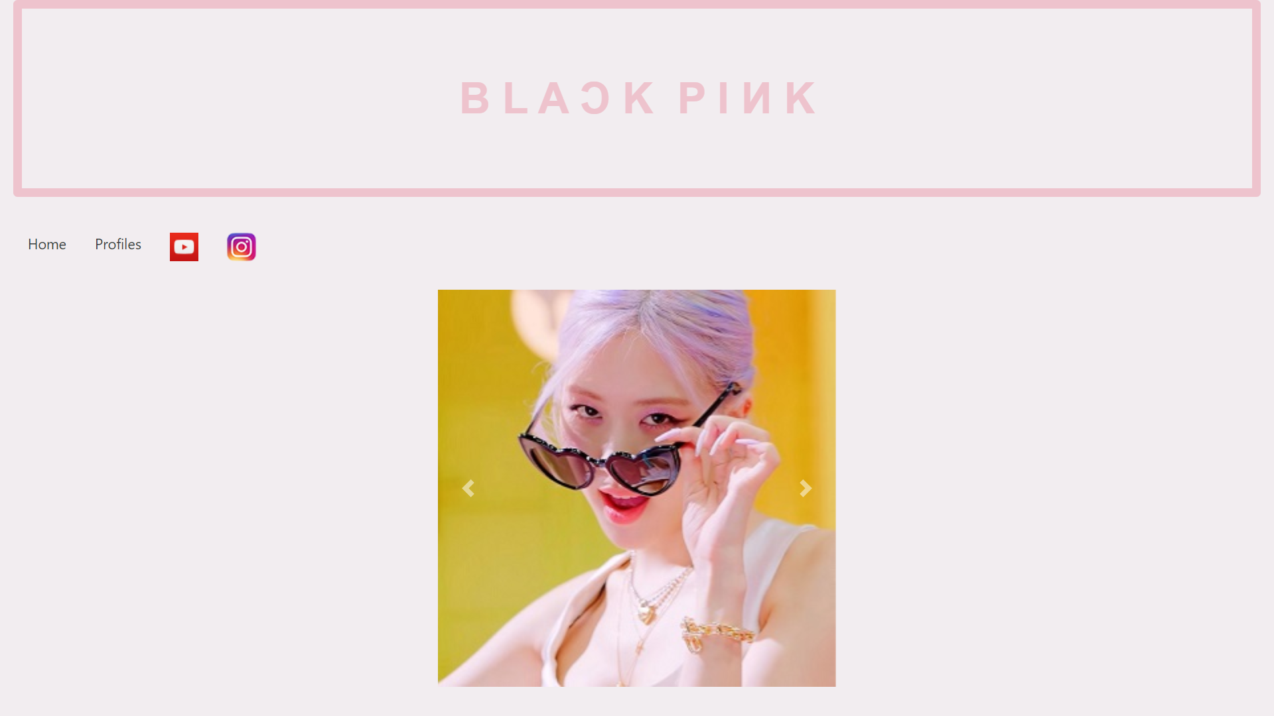
2. Profile  
   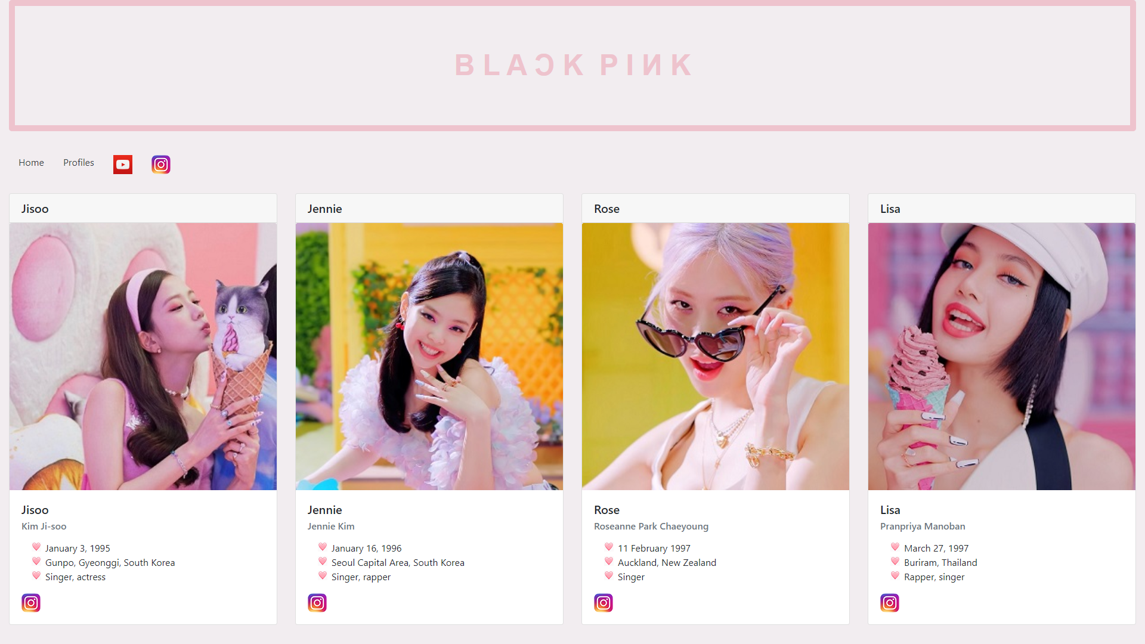  
   1. When viewed on screen whose width is smaller than md, the cards are stacked vertically.  
      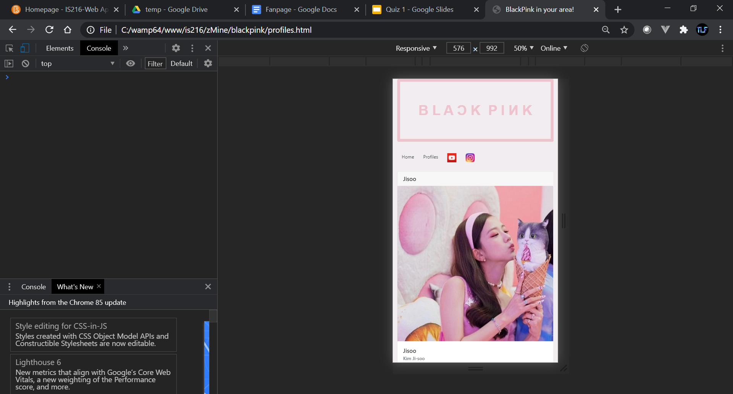

**Part 2.** Create another home page

1. Vertical Menu
   1. Link to youtube channel
   2. Link to Instagram page
2. Carousel of Cards of members’ profiles

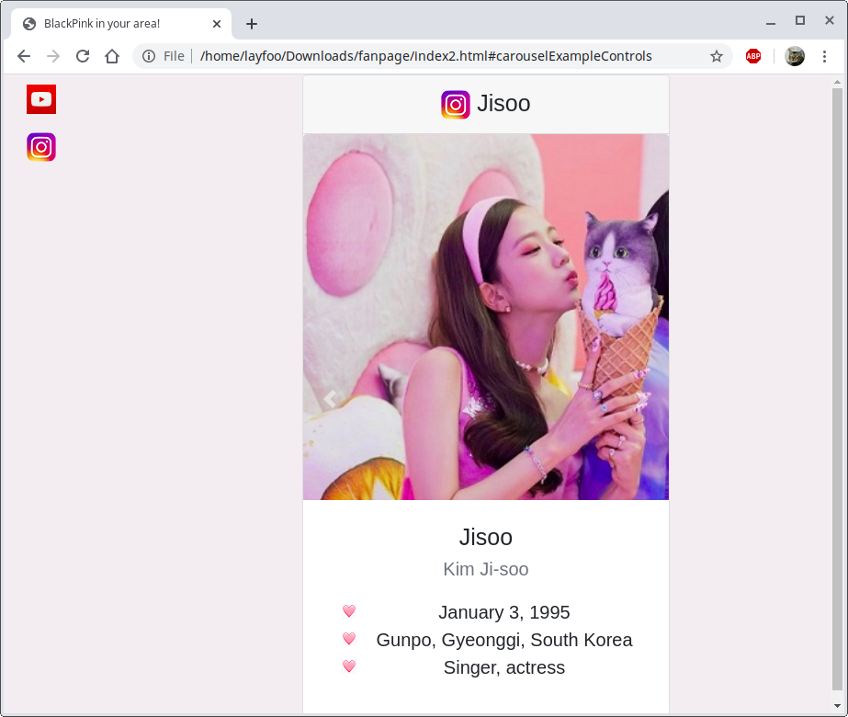

When viewed on screen whose width is smaller than sm

|  |  |
| --- | --- |
|  | When you click the hamburger |

**Question 2 – Registration Page (*)**

Go to register directory.

|--register

|-- register.html

Complete register.html with appropriate CSS styling available from Bootstrap.com (getboostrap.com) such that the following responsive web page can be displayed on a web browser.

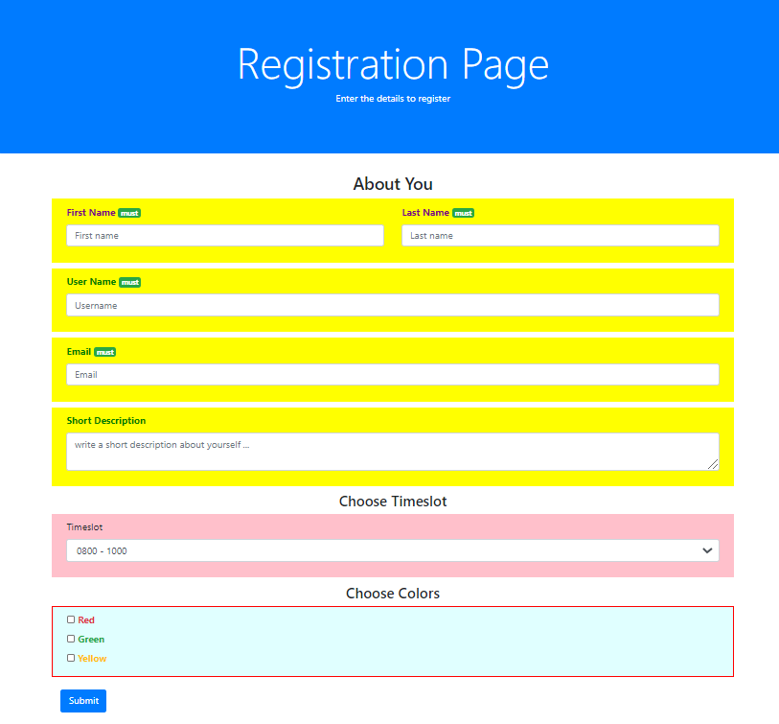

**Question 3 – Food Mart (*)**

Go to foodmart directory.

|--foodmart

|-- images

|-- <food pictures>

|-- foodmart.html

Complete foodmart.html with appropriate CSS styling available from Bootstrap.com (getboostrap.com) such that the following responsive web page can be displayed on a web browser as shown in Figure 1 and Figure 2.

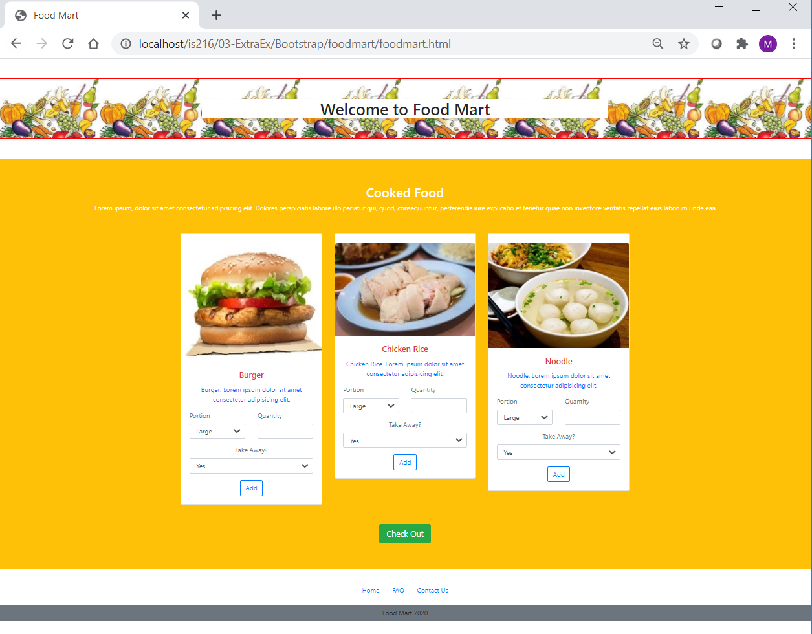

Figure 1: Full screen at 100%

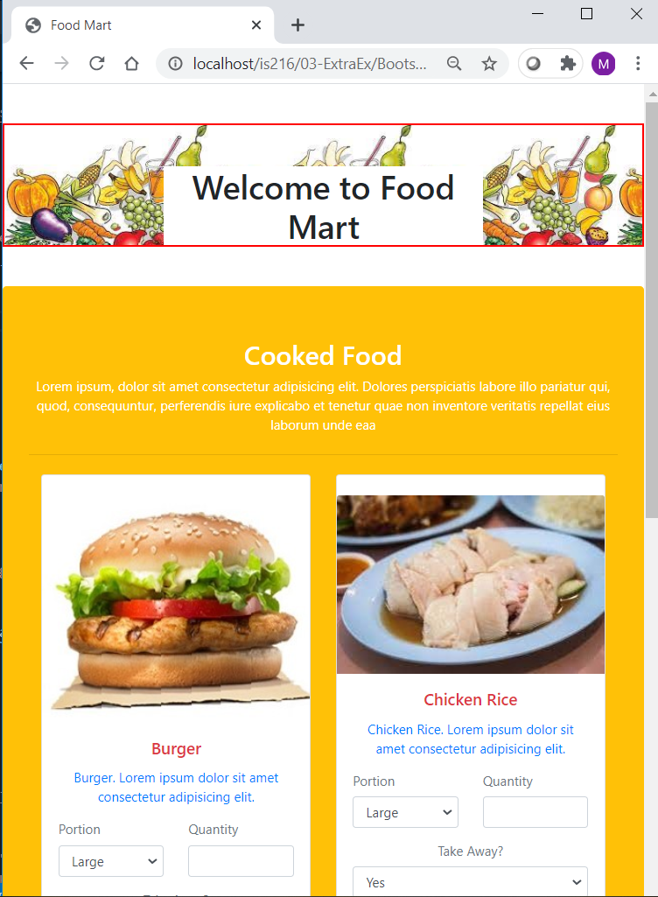

Figure 2: Web page display at a smaller viewpoint width

**Question 4 – News (**)**

Go to news directory.

|-- news

|-- img

|-- journalist.png, news.png, thumb_news.png

|-- news.html

Complete news.html with appropriate CSS styling available from Bootstrap.com (getboostrap.com) such that the following responsive web page can be displayed on a web browser as shown in the following Figure. Use minimal vanilla CSS.

